**Mini Project Report**

on

**TRAVEL & TOURISM WEBSITE**

Submitted to

**Ajay Kumar Garg Engineering College, Ghaziabad**



(B. Tech Information Technology Sem 5th, 2021-22)

(KCS-554 Project Mini Project or Internship Assessment Report)

**Submitted to: -**

Mr. Sarvachan Verma (Asst. Prof. IT)

**Submitted by: -**

Priya Karnwal (1900270130124)

Pranjal Srivastava (1900270130120)

**Acknowledgement**

This project is the work of several days’ study on various aspects of HTML, CSS, BOOTSTRAP, JAVA SCRIPT, PHP and MySQL Project. During the work, we have received a great amount of help from our Director General “**Dr. R.K. Agarwal**”, of **AJAY KUMAR GARG ENGINEERING COLLEGE**, whom we wish to acknowledge andthank from the depth of our hearts.

We are grateful to “**Dr. Anu Chaudhary**” our HOD of IT Department, for giving us this golden opportunity to learn and showcase our skills through project work.

We are very much obliged and thankful to “**Mr. Sarvachan Verma**”, our coordinator for providing this opportunity and constant guidance given by him during the course.

At last, but not the least, we would like to show gratitude to all our friends for their support and guidance.

1

**ABSTRACT**

The project “TRAVEL AND TOURISM WEBSITE” is used to automate all process of the travel and tourism, which deals with creation, booking and confirmation and user details. The project is designed HTML-CSS-JS as front end and PHP-JS-MySQL as backend which works in any browsers.

The website covers all the areas required for an including tourism, this project is developed to manage the tourist in the tourism management web site. The main module in this project are login, tourist management, complaints and reports.

2

**TABLE OF CONTENT**

|  |  |  |  |
| --- | --- | --- | --- |
| I. | Acknowledgments | 1 |  |
|  |  |  |
|  |  |  |  |
| II. | Abstract | 2 |  |
|  |  |  |
| III. | Table of contents | 3 |  |
|  |  |  |
| IV. | Introduction | 4 |  |
|  |  |  |
| V. | Problem statement | 5 |  |
|  |  |  |
| VI. | Description | 6 |  |
|  |  |  |
| VII. | Hardware/Software Requirements | 7 |  |
|  |  |  |
|  |  |  |  |
|  | SRS with USE CASE Diagram | 8 |  |
| VIII. | Data flow Diagram | 9 |  |
|  |  |  |
|  |  |  |  |
| IX. | Code | 10 |  |
|  |  |  |
|  |  |  |  |
| X**.** | Test Results | 16 |  |
|  |  |  |  |

3

**INTRODUCTION**

* Tourism has turned out to be an economic booster contributing to the economic development of many countries over the last few decades. People see holidays as a necessity, and not as luxury in the present scenario. Tourism calls for coordination and cooperation between travel agents, tour operators, and tourists.

Tourism has a few major elements − destinations, attractions, sites, accommodation, and all auxiliary services. The need for a robust and dynamic tourism management application has been around since the advent of the tourism concept.

* Thus we have developed an application to provide the best travelling services to the customers and travel agents. The Tourism Management System provides a search platform where a tourist can find their tour places according to their choices. This system also helps to promote responsible and interesting tourism so that people can enjoy their holidays at their favourable places and develop tourism with different cultures so that they enrich the tourism experience and build pride.
* This project is designed with SQL Server as back end. All the data will be stored in the server and in case of any data losing situation, a backup will be available by this server. The details related to every aspect of the tourist will be available separately. The admins just have to click once and all the details will be available to them.

4

**Problem Statement**

* The purpose of website is established fact that internet users are increasing day-by-day. One of the main purposes of the website is to facilitate the offline customer online because customers cannot spend their precious time in markets trying to find out the best deal.
* India is a country where in a few days’ holiday, you can enjoy a lot. The problem is that we although having many websites but they offer different kind of services. The customers are enjoying a lot but there is a lack of relationship between travel agency & customers and hence we are establishing that relationship by caring and serving all customers in the same manner that we wish to be served.

**Objective & Scope**

* Our objective is to make strong relationship with customers so that they can enjoy the holiday of their dreams.
* Provide a high standard of services suitable for individuals seeking relaxing, comfortable and memorable experiences.
* Produce expeditions and memories that would satisfy each and every single of the customers.

5

**Implementation Methodology/Description: -**

* It is proposed that the system should have the following modules:

o

**Admin Module** - This module is mainly based on admin. System will check the

o

o

admin user name and password for authentication. After the verification for

authorization the admin can be able to precede the process. All works are done

under his control.

**User Module -** This module covers the details about the registration of users

which they can be register by itself by adding data like name, password, email id

and further details. After registration they can be sign in by their username and

password.

**Package Creation -** The admin can create packages by creating package page which the type, price, details, place details all the travel tour package details can be added here. Which it will be showed in user homepage.

o

o

o

**Package Booking** - In this module, maintain the booking of travel packages by the user by selecting a various package with date and certain comments.

**Booking Confirmation/Manage Booking** - Confirmation is the process of confirming the booked packages by the admin that is booked by the user with date and comment. Also admin can manage the booking by cancelling.

**Issue Ticket** - Tickets can be issued for the user in the issue ticket page in the homepage of user the certain booked packages only can be issued.

6

**Hardware Requirements: -**

The minimum hardware requirement specifications for developing this project are as follows:

* Processor: intel i3 with speed of 1.2 GHz
* RAM: 2 GB
* Hard Disk: 256 GB
* Monitor: Standard colour monitor
* Key Board: Standard keyboard
* Mouse: Two or Three button mouse

**Software Requirements: -**

The minimum software requirement specifications for developing this project are as follows:

* Operating System: Windows
* Technology: PHP
* Web Technologies: HTML, CSS, JS
* IDE: Notepad++, Microsoft VS Code
* Web Server: XAMPP v3.2.4
* Database: MySQL

7

**SRS WITH USE CASE DIAGRAM**

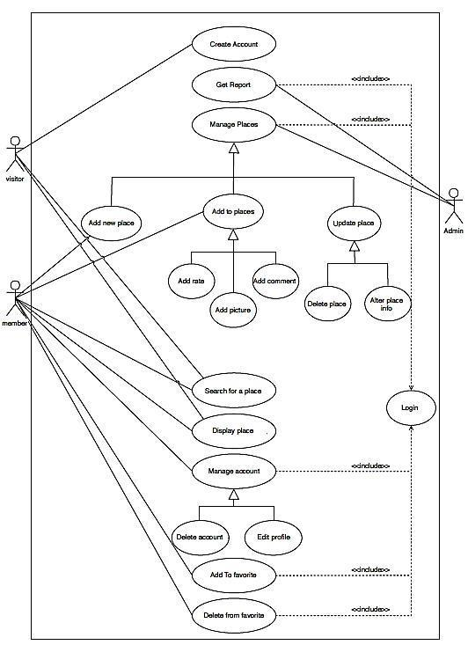

8

**DATA FLOW DIAGRAM**

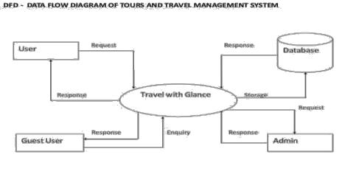

9

**CODE**

* **Home Page Code: -**
* **Index.html**

<!DOCTYPE html>

<html>

<head>

<meta charset="utf-8">

<meta name="viewport" width="device-width, initial-scale=1.0"> <link rel="shortcut icon" type="image" href="images/icon.png">

<title>Travel Bliss | best travel itinerary</title>

<!-- CSS file link -->

<link rel="stylesheet" type="text/css" href="css/styles.css?v=<?php echo time(); ?>">

<!-- Font Awesome link -->

<script

src="https://use.fontawesome.com/releases/v5.15.4/js/all.js"></script>

<!-- Font Style -->

<link

href="https://fonts.googleapis.com/css2?family=Montserrat&family=Roboto:ital@1&di

splay=swap" rel="stylesheet">

<!-- Bootstrap links -->

<link rel="stylesheet"

href="https://maxcdn.bootstrapcdn.com/bootstrap/4.0.0/css/bootstrap.min.css">

<script src="https://code.jquery.com/jquery-3.2.1.slim.min.js"></script> <script

src="https://cdnjs.cloudflare.com/ajax/libs/popper.js/1.12.9/umd/popper.min.js">< /script>

<script

src="https://maxcdn.bootstrapcdn.com/bootstrap/4.0.0/js/bootstrap.min.js"></scrip

t>

</head>

<body>

|  |  |  |
| --- | --- | --- |
| <!-- | Title --> |  |
| <section | id="title"> |  |
| <div | class="container-fluid"> | 10 |

<?php include "includes/header.php"?>

<!-- Carousel -->

<div class="row">

<div class="col-lg-3 title-text">

<div class="title-inner-text">

<h2>A New Way To Plan Your Trip</h2>

<p>Create a customized day by day itinerary for free</p> <button class="btn btn-md btn-dark"><i class="fas fa-map-

marker-alt"></i> Plan a trip</button>

</div>

</div>

<div class="col-lg-9">

<div class="carousel slide" id="testimonials-slide" data-ride="carousel" data-interval="3000">

<div class="carousel-inner">

<div class="carousel-item active">

<img class="carousel-img" src="images/taj-

mahal.jpg" alt="taj mahal" height="550" width="100%" fixed> </div>

<div class="carousel-item">

<img class="carousel-img" src="images/tea-

estates.jpg" alt="tea-estates" height="550" width="100%"> </div>

<div class="carousel-item">

<img class="carousel-img" src="images/mysore-

palace.jpg" alt="mysore-palace" height="550" width="100%"> </div>

<div class="carousel-item">

<img class="carousel-img" src="images/kerela.jpg" alt="kerela" height="550" width="100%">

</div>

<div class="carousel-item">

<img class="carousel-img" src="images/gateway-of-

india.jpg" alt="gateway-of-india" height="550" width="100%">

</div>

|  |  |
| --- | --- |
| </div> |  |
| </div> |  |
| </div> |  |
| </div> |  |
| </div> |  |
| </section> | 11 |

|  |  |
| --- | --- |
| <!-- | Features --> |
| <section | id="features"> |
| <div | class="row"> |

<div class="col-lg-4">

<img class="features-img" src="images/add-plan.png">

<h3 class="features-heading">Add places from guides with 1

click</h3>

<p class="features-para">We crawled the web so you don’t have to. Easily save mentioned places.</p>

</div>

<div class="col-lg-4">

<img class="features-img" src="images/routes.png">

<h3 class="features-heading">Optimize your route</h3>

<p class="features-para">Make the most of your day. We’ll plan the best route to visit your must-sees.</p>

</div>

<div class="col-lg-4">

<img class="features-img" src="images/recommendation.png">

<h3 class="features-heading">Get personalized suggestions</h3>

<p class="features-para">Find the best places to visit with smart recommendations based on your itinerary.</p>

</div>

</div>

</section>

<!-- Cards -->

<section id="cards">

<div class="card-text">

<h2>Discover your next favorite destination</h2>

<p>Get inspired from guides around all over India — with expert tips and recommendations from the <strong>Travel Bliss</strong> community.</p>

</div>

<div class="row">

<div class="col-lg-3 col-md-6">

<div class="card">

<img src="images/gateway-of-india2.jpg" height="300"

width="300">

</div>

</div>

<div class="col-lg-3 col-md-6">

<div class="card">

<img src="images/howrah-bridge.jpg" height="300" width="300"> </div>

</div> 12

<div class="col-lg-3 col-md-6">

<div class="card">

<img src="images/goa.jpg" height="300" width="300"> </div>

</div>

<div class="col-lg-3 col-md-6">

<div class="card">

<img src="images/manali.jpg" height="300" width="300"> </div>

</div>

</div>

</section>

<!-- Footer -->

<footer id="footer">

<div class="row">

<div class="col-lg-4">

<h2>Destination</h2>

<hr>

<ul>

<li><a href="agra.html">Agra</a></li>

<li><a href="goa.html">Goa</a></li>

<li><a href="kochi.html">Kochi</a></li>

<li><a href="kolkata.html">Kolkata</a></li>

<li><a href="mumbai.html">Mumbai</a></li>

<li><a href="mysore.html">Mysore</a></li>

<li><a href="new-delhi.html">New Delhi</a></li> </ul>

</div>

<div class="col-lg-4">

<h2>Contact Us</h2>

<hr>

<i class="social-icon fab fa-twitter"></i>

<i class="social-icon fab fa-facebook-f"></i> <i class="social-icon fab fa-instagram"></i> <i class="social-icon fas fa-envelope"></i> <br><br>

<span>Email : <a

href="mailto:travelbliss@gmail.com">travelbliss@gmail.com</a></span>

<br><br>

<span>Mobile No. : 8451529631</span>

</div>

<div class="col-lg-4">

<h2>About Us</h2>

<hr>

<h6>The best group itinerary planner</h6>

<p>Use <strong>Travel Bliss</strong> to share your itinerary with tripmates, friends, and families and collaborate in real time, so everyone stays in the loop.</p>

</div>

</div>

</footer>

</body>

</html>

* **Styles.css**

*{

*margin*: 0;

*padding*: 0;

}

html,body

{

*width*: 100%;

*height*: 100%;

*overflow-x*: hidden;

}

/*Title*/

.title-text{

*color*: white;

*background-color*: dimgrey;

}

.title-inner-text{

*position*: relative;

*top*: 150px;

}

/*Features*/

#features{

*padding*: 60px 0 100px;

*width*: 90%;

*margin*: auto;

*text-align*: center;

}

.features-img{

*width*: 280px;

*height*: 160px;

*padding*: 20px;

|  |  |
| --- | --- |
| } | 14 |

.features-heading{

*font-size*: 1.2rem;

}

.features-para{

*font-size*: 0.75rem;

*width*: 60%;

*margin*: auto;

}

/*Cards*/

#cards{

*text-align*: center;

*padding*: 30px 50px 60px 30px;

*background-color*: #3f84b1;

*color*: white;

}

.card-text{

*padding*: 10px 0 20px;

*width*: 50%;

*margin*: auto;

}

/*Footer*/

#footer{

*text-align*: center;

*padding*: 50px 40px 50px 0;

*margin*: auto;

*background*: silver;

}

#footer ul li{

*list-style*: none;

}

#footer a{

*padding*: 5px;

*text-decoration*: none;

*color*: blue;

}

#footer a:hover{

*color*: red;

}

#footer hr{

*width*: 60%;

*margin*: auto;

*padding*: 15px 0;

}

.social-icon{

*padding*: 5px;

*font-size*: 2.5rem;

|  |  |
| --- | --- |
| } | 15 |

**TEST RESULT**

* **Home Page: -**

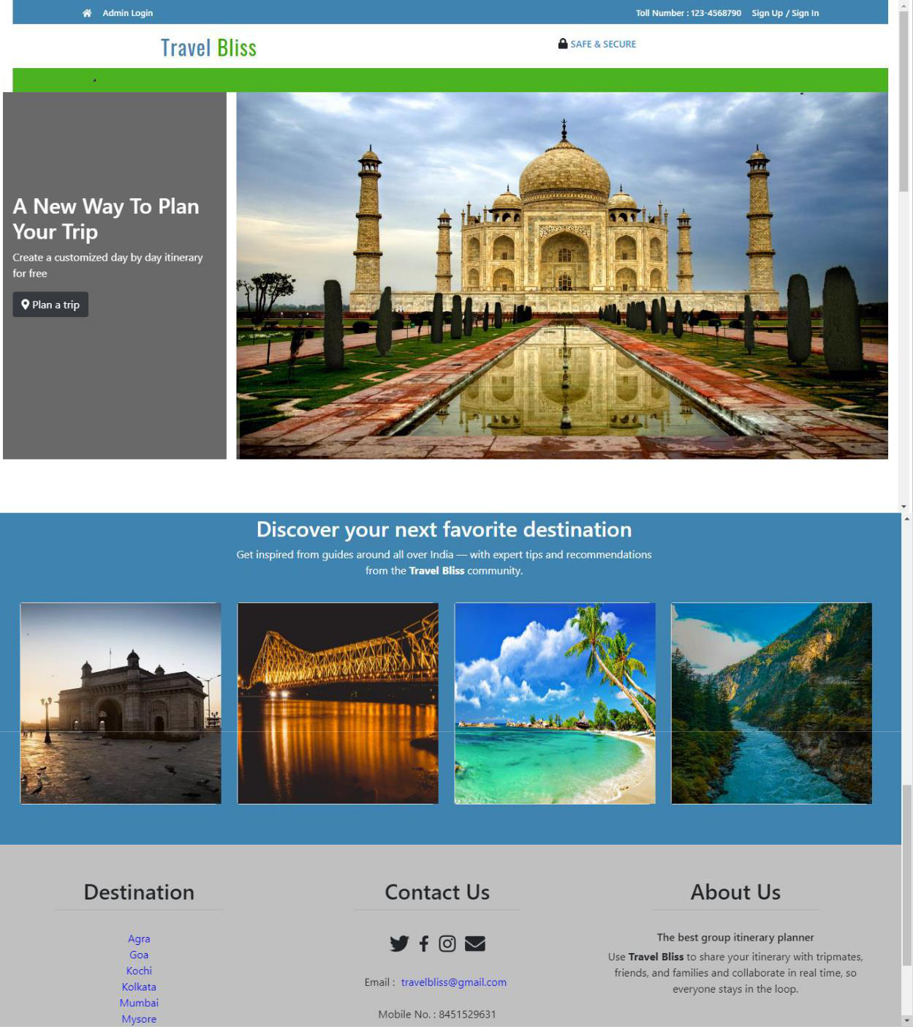

16

* **Admin Login: -**

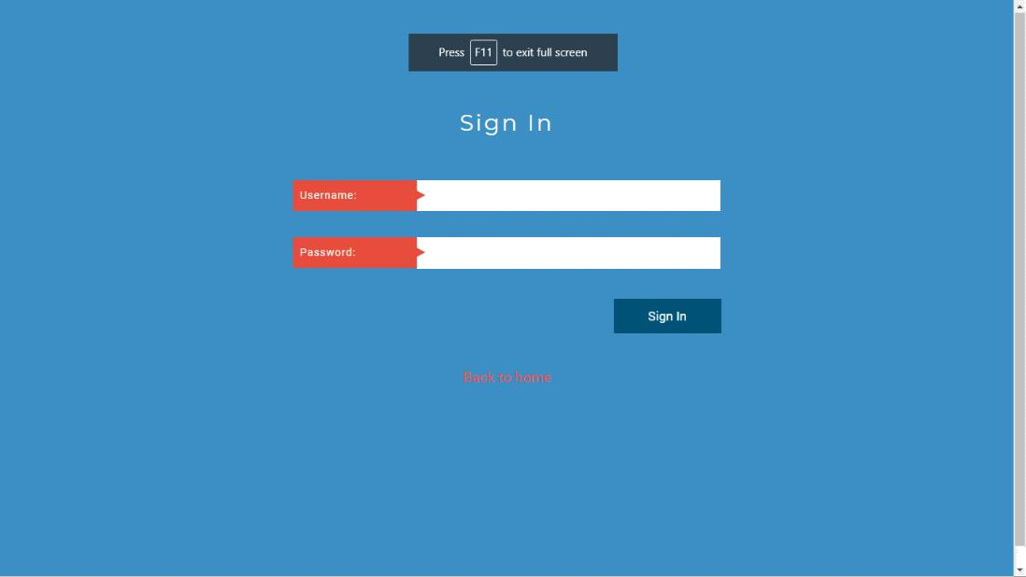

* **Admin Dashboard: -**

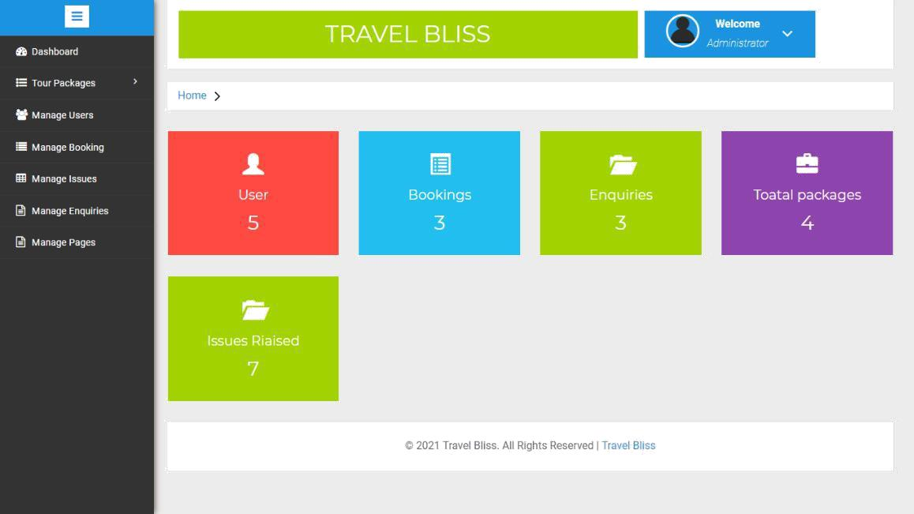

17

* **Admin User Manage Panel: -**

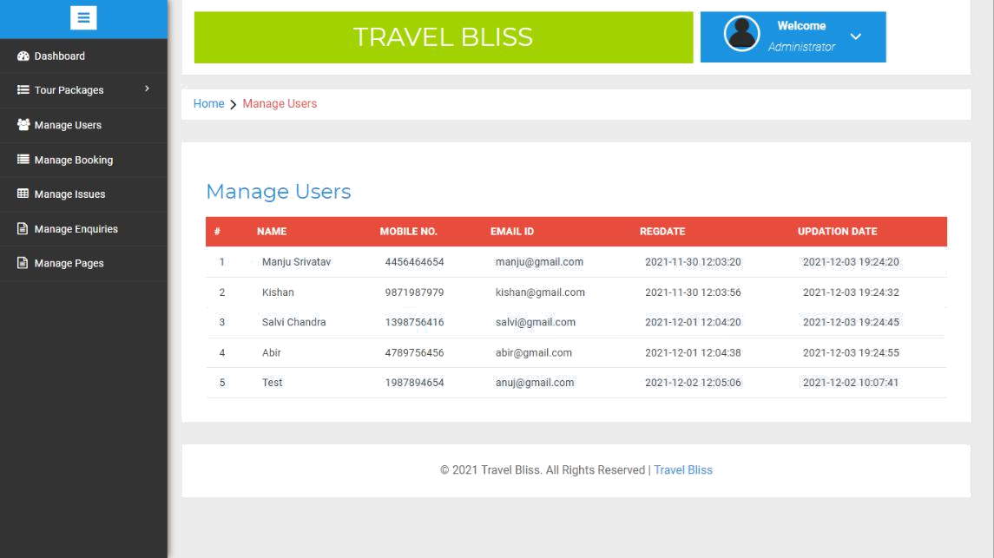

* **Admin Enquiry Manage Panel: -**

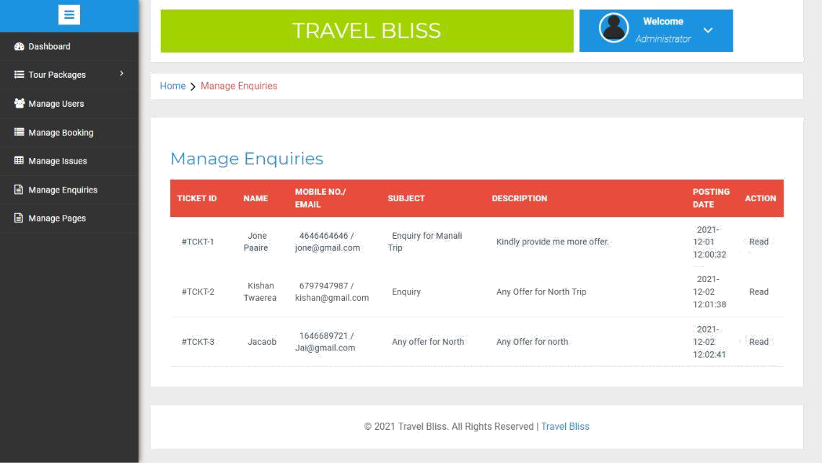

18

* **User Login: -**

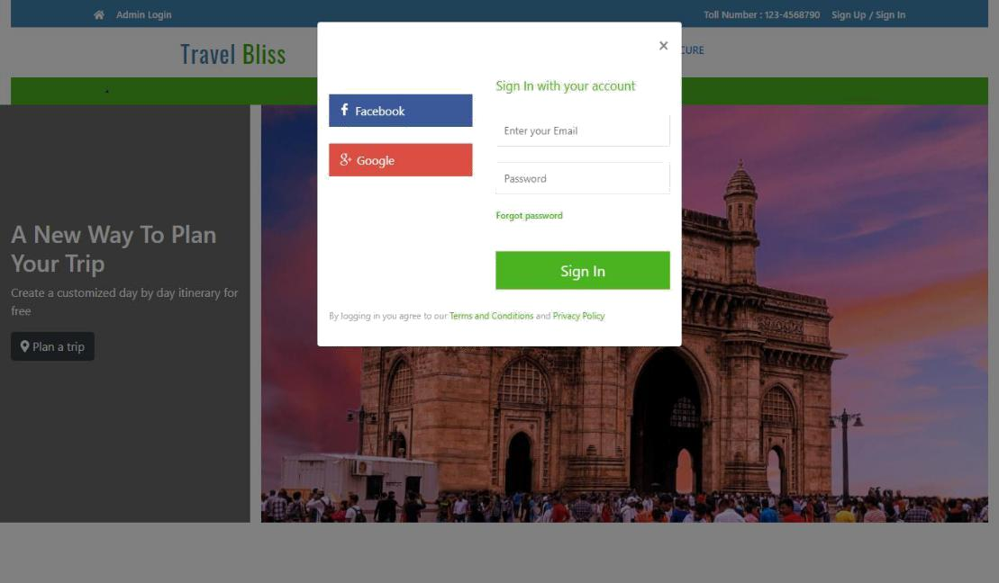

* **User Register: -**

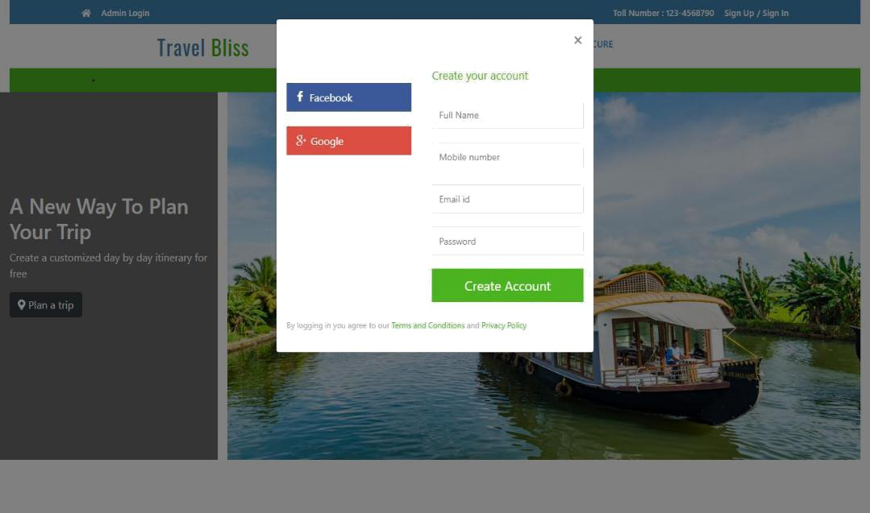

19

* **User Profile Page: -**

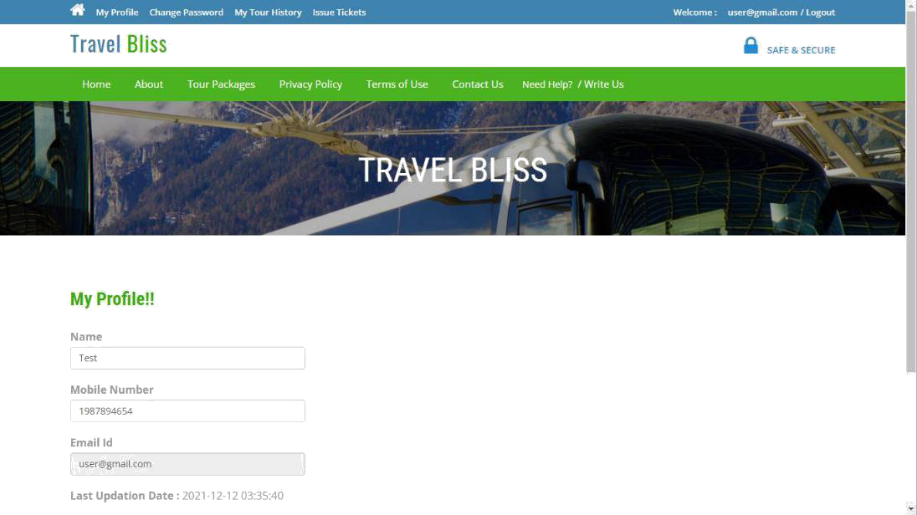

* **Package List Page: -**

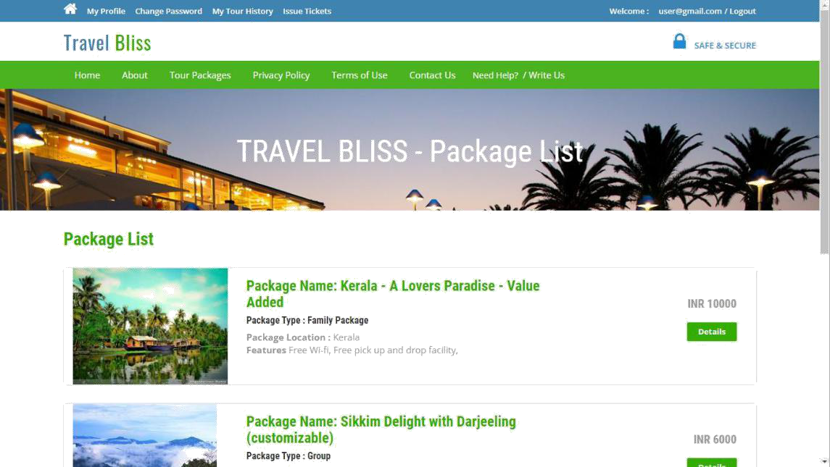

20

* **User Password Change: -**

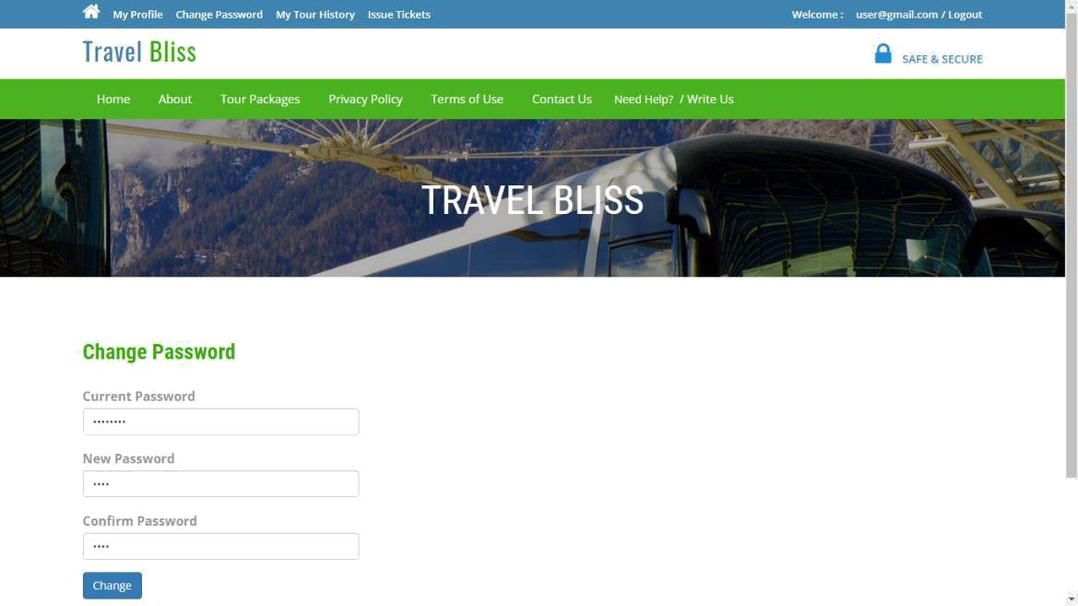

* **Help Request: -**

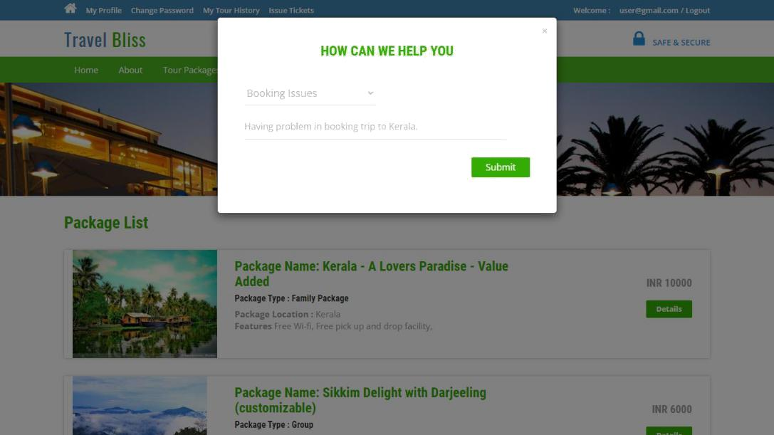

21